Chinese Characters

Mandarin is the most common spoken language in the world, with over 1 billion global speakers! The spoken language is tonal, however, the written characters are pictorial symbols that represent words.

What do you think these pictures mean? Have a go!

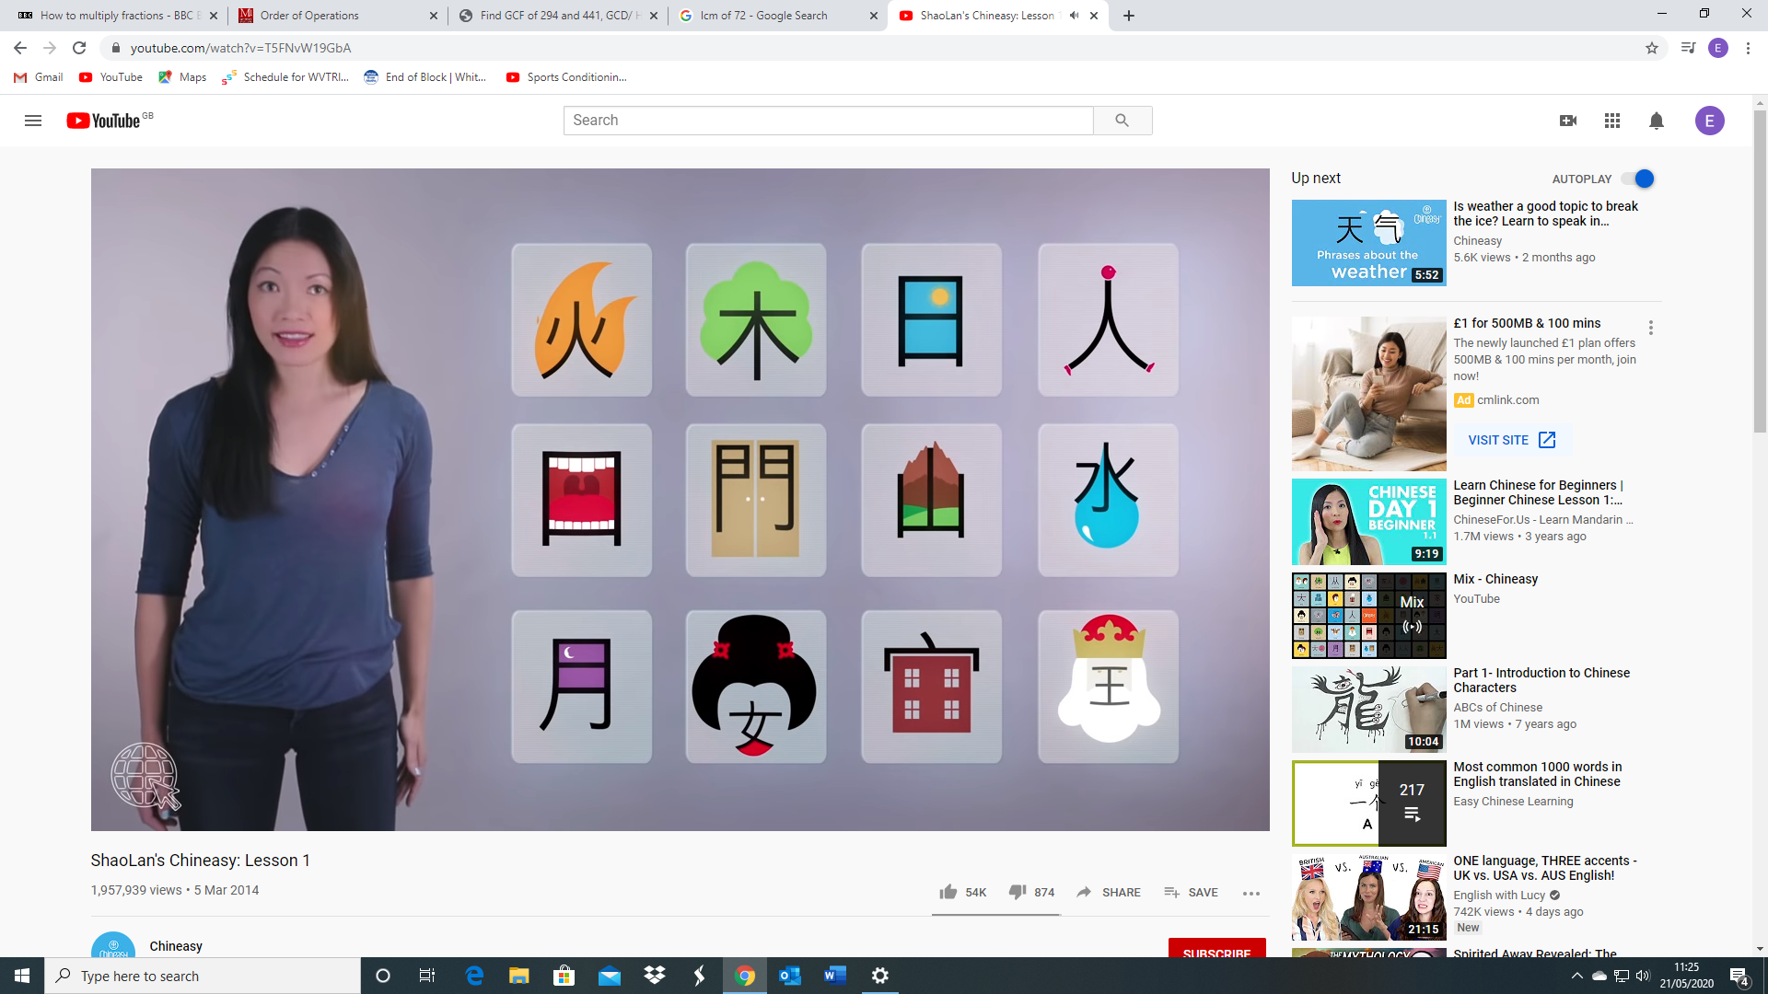

<https://www.youtube.com/watch?v=04Jj9cCrpbA>

<https://www.youtube.com/watch?v=y26VZ0_qtYo>

<https://www.youtube.com/watch?v=DWtwPdMuR-0>

(Writing numbers from 1-10 on Chinese paper)

